Name _____________________________________________
Effects of Great Depression Notes

Do Now: Grapes of Wrath excerpt ___________________________________ ____________________________________ ____________________________________ ____________________________________
Dust Bowl (describe): _____________________________________________ _____________________________________________
_____________________________________________
_____________________________________________ _____________________________________________
Reaction from farmers: ______________________ ___________________________________________
Arkies: ______________________________________________________
Oakies: ______________________________________________________
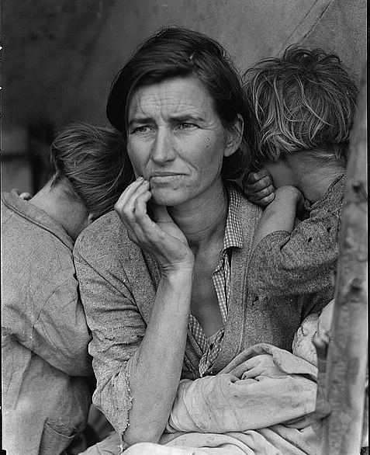
“Migrant Mother” reaction ________________________________________ ________________________________________ ________________________________________ ________________________________________ ________________________________________ ________________________________________ ________________________________________ ________________________________________ ________________________________________ _______________________________________ _______________________________________ _______________________________________ ________________________________________

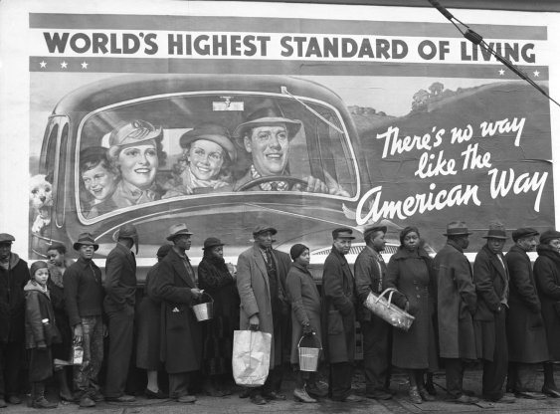

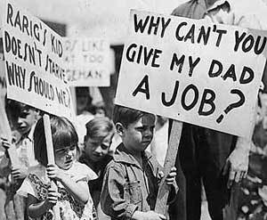
Unemployment/ Joblessness (anlalyze graph) __________________________________ __________________________________________________________________________________________________________________________________________________ _________________________________________________________________________
#2 Unemployment Stomp:

Hoovervilles: ______________________________________________________________ __________________________________________________________________________________________________________________________________________________
#5 We’d Like to Thank You Herbert Hoover (Annie)
What was the popular opinion of President Hoovers reaction to the Depression ? ______ __________________________________________________________________________________________________________________________________________________
Bonus Army _____________________________________________________________ _________________________________________________________________________________________________________________________________________________

