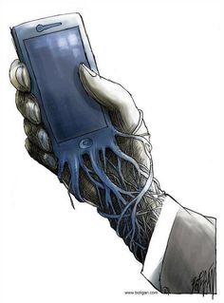
Smartphone/ Technology Fast

(24hours) Extra Credit
Chose 1 day
- Turn your phone/ Ipad off or leave it home
- No music, no checking time, no answering texts
- Complete Reflection questions below
- Show Mrs. Argus your data usage screen for that time period (may be asked to prove it is your phone
Tips: warn people that you are fasting and that you will not be responding for 24 hours and turn notifications and noises off
Reflection (can be written, audio, or video reflection)
- How long in to the fast did you begin to feel different? What emotion would you say you were experiencing?
- Describe your day at or around the 12th hour of not having your phone
- Describe your day at or around the 20th hour of not having your phone
- Reflect on the entire day
- Reflect on the day after (did you feel you missed anything? Response from your friends or family that you were off line, etc.
- Did you find that have an addiction? Explain

