Zyair Civic Action Project Step 2 we in here like booty hair , thug life
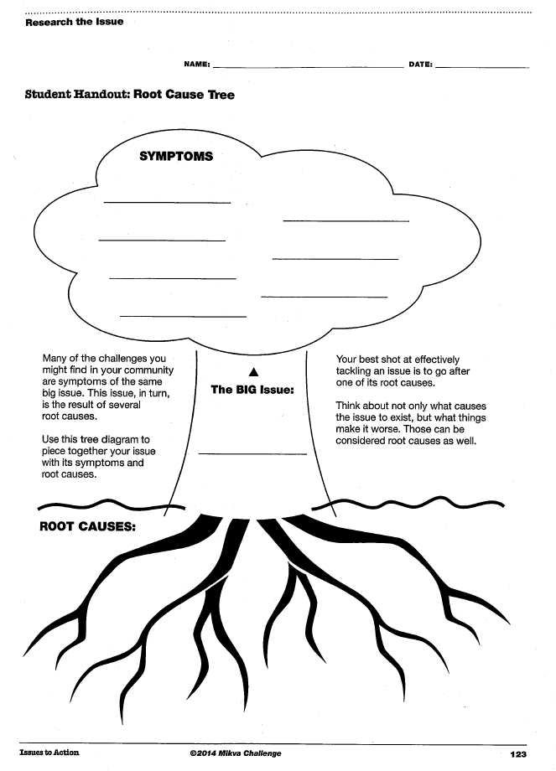
Researching a Public Issue for your Civic Action Project

Explain and your personal connection to issue (why this?)
II. Complete preliminary research about issue.
What root cause am I researching? ___________________________________________ ________________________________________________________________________

Root cause in research question format _______________________________________ ____________________________________________________________________________________________________________________________________________________

Possible Search terms ________________________________________________________ ____________________________________________________________________________________________________________________________________________________
Quick survey before diving in to research: if you can’t check all three boxes, start again

Can I easily find 3 sources of info on this issue?
Am I finding support for my side of issue?
Do others care about this issue?

V. 2 Search a variety of sources. Look for information from various sources,
Suggested Research Source List:
- www.scsd .us / library links/ eresources / opposing viewpoints
- www.procon.org
- www.scsd .us / library links/ eresources / infotrac newsstand
- mainstream new sources (cnn, foxnews, 9wsyr, cnycentral, Syracuse.com
VI. Organize the information you find. Use chart
Who does your issue impact?  Look at issue from all sides. | National
 | State
 | Local
VI. Organize the information you find. Use chart
What is th historical root of this issue? | National
 | State
 | Local

What has been done to attempt change on this issue?  Evaluate the success of the effort. | National
 | State
 | Local

What government agencies, or people are responsible for dealing with this issue? | National
 | State
 | Local

What is your suggested change for this issue?  This is the bulk of your portfilio. | National
 | State
 | Local

Bibliography (at least 3 creditable sources)
- __________________________________________________________________________________________________________________________
- __________________________________________________________________________________________________________________________
- __________________________________________________________________________________________________________________________

